[Access via Mobile]
- When you access to the link, the following page will be shown at first.

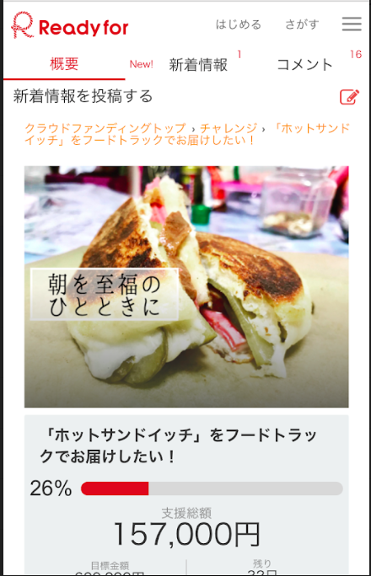

- Scroll down to the following point and click the black-circled part (NEXT).

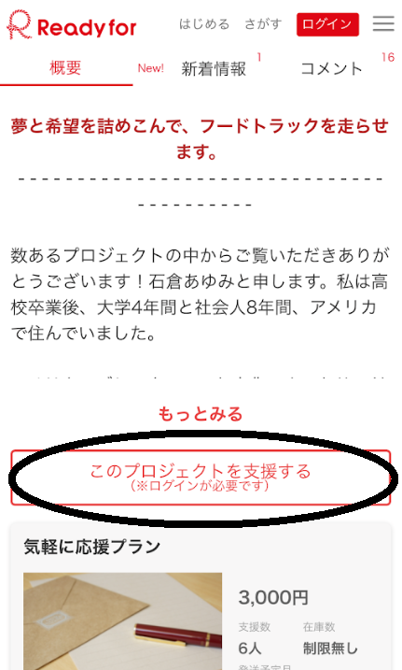

- Reach to Log in screen in which you can choose either via making new account or FB.

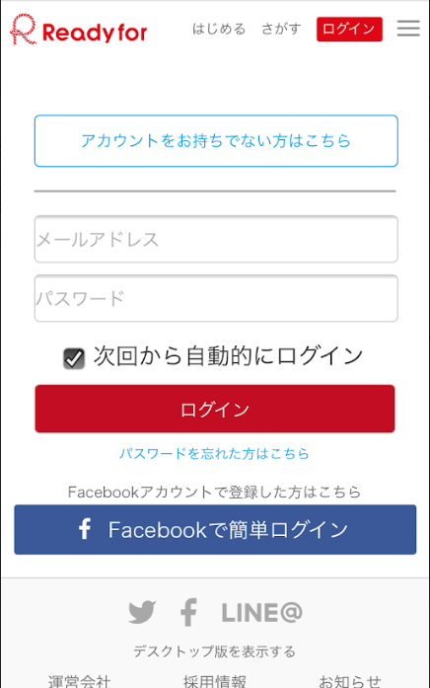
New Account Login
Facebook Login

3a. Create New Account (not preferable): you’ll have the following extra columns. From the top, Your Name, Email Address, Password (you can put anything here for PW), re PW. Then, click the black-circled part (NEXT).

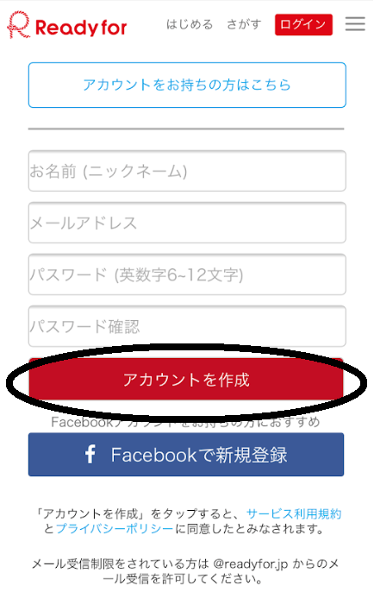
Will receive the confirmation email with link. Click it and will reach to the top so type “フードトラック(food truck)” in Japanese (this is the most annoying part!!). Then leads you to the first page so go ahead to proceed 2.

3b. Facebook Login (preferable): Type your registered email address and PW. Then leads you to the following page.

Click the little down-arrow and choose the number (e.g. if you go under 10,000 yen and choose 2, you eventually pay 20,000 yen)

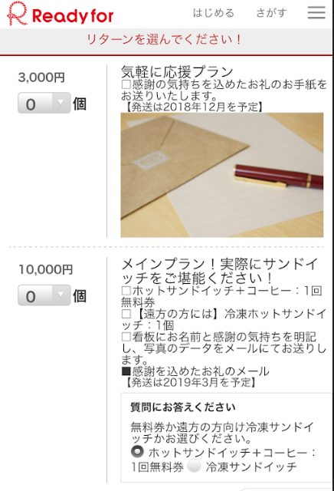
3,000 yen – Thank You Letter (Donation)

10,000 yen – Free ticket (1 hot sandwich + coffee) + Your name will be written on the store board (the photo will be sent to you) + Thank You Letter
*If you live far or wish, 1 frozen sandwich will be sent to you

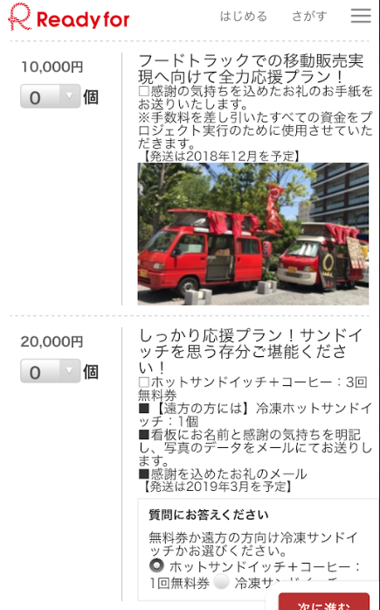
10,000 yen – Thank You letter (Donation)

20,000 yen - Free ticket (3 hot sandwiches + 3 coffees) + Your name will be written on the store board (the photo will be sent to you) + Thank You Letter
*If you live far or wish, 3 frozen sandwiches will be sent to you

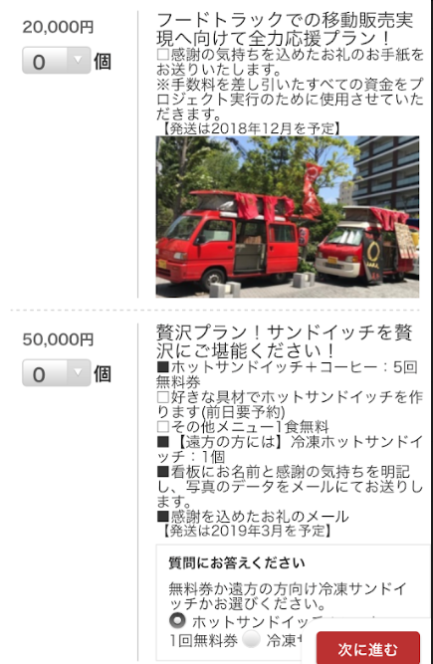
20,000 yen - Thank You Letter (Donation)

50,000 yen - Free ticket (5 hot sandwiches + 5 coffees) + 1 Free Custom Hot Sandwich + 1 Free Other Menu + Your name will be written on the store board (the photo will be sent to you) + Thank You Letter
*If you live far or wish, 5 frozen sandwiches will be sent to you

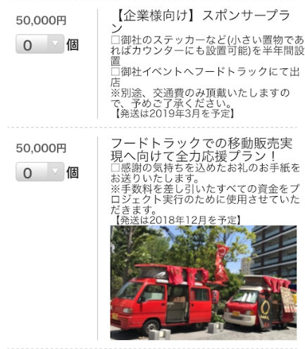
50,000 yen – Company Sponsor Plan (the company which is willing to support my truck)
Company Logo Sticker is welcome! I’ll come wherever you want me to (Gas fee is required)

50,000 yen - Thank You Letter (Donation)
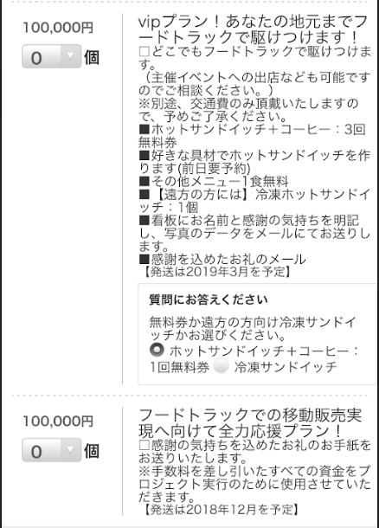
100,000 yen – VIP Plan (I’ll come wherever you want me to (Gas fee is required)) + Free ticket (3 hot sandwiches + 3 coffees) + 1 Free Custom Hot Sandwich + 1 Free Other Menu + Your name will be written on the store board (the photo will be sent to you) + Thank You Letter
*If you live far or wish, 5 frozen sandwiches will be sent to you

100,000 yen - Thank You Letter (Donation)
- When you choose the price to support and the number, scroll down to the bottom until you see this payment section. Click the circle next to VISA and click the black-circled part (NEXT).

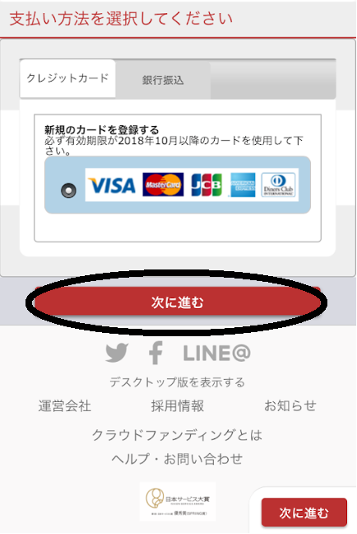

- Type your credit card number and choose expiration date.

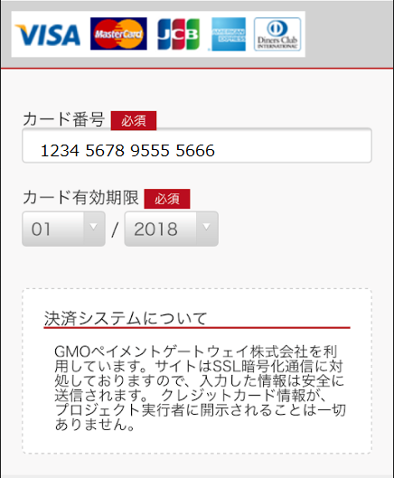

- Scroll down and copy/paste yello-highlighted parts.

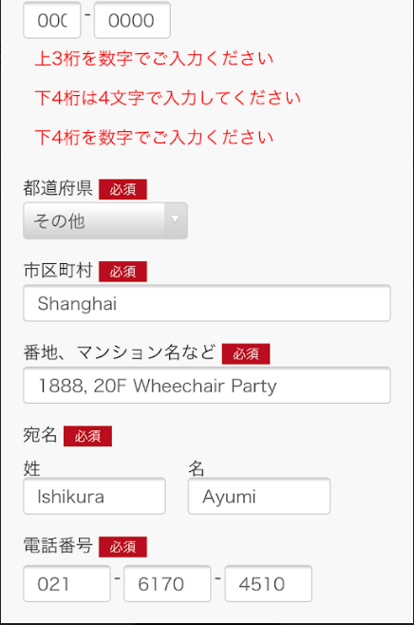
郵便番号(Postal Code): 187-0021
都道府県 (Province/State): scroll down and choose 東京 (Tokyo)
市区町村 (City): 小平市 (copy and paste)
番地、マンション名など (other): 上水南町1-26-13 (copy and paste)

姓 (Last Name): please type your last name
名 (First Name): please type your first name

電話番号(Phone Number): 080-6582-0702

Once you finish putting all the required information, scroll down to the bottom and click the black-circled part (NEXT).

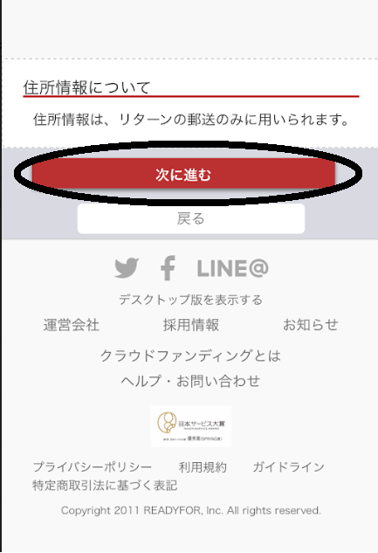

- Scroll down and click the black-circled part (Payment Confirmation). Done!!!!

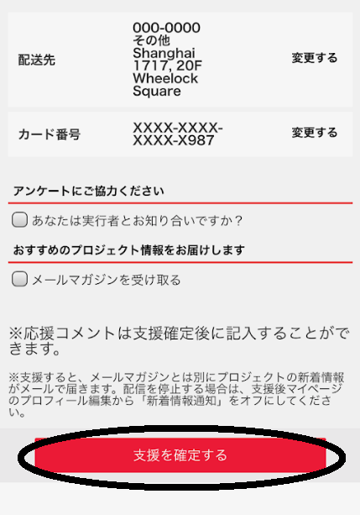
Tick here
Do Not Tick

